Documentation of Fertilizer in GCAM
Page Kyle
February 17, 2012

Summary
A full nitrogen (N) fertilizer module has been developed for GCAM 3.0, with production technologies in each region consistent with available data on ammonia production, and consumption downscaled to region, crop, and AEZ. In GCAM, N fertilizer is indicated in mass of fixed N. Production and consumption by country (and therefore region) are from FAO ResourceSTAT (FAOSTAT 2011a), with production totals uniformly adjusted downwards so that the global total is equal to global total consumption, excluding non-agricultural uses of N fertilizer. Production by technology is from IEA (2007), which indicates both the shares of the different production technologies used in each of eleven global regions, in addition to the energy intensity of the technologies used in each region. In this version several East Asian regions had to have minor adjustments to the IEA’s data in order to avoid the inputs to fertilizer manufacturing exceeding the region’s industrial energy or feedstock use of natural gas. Future changes to regions will likely need to be accompanied by similar adjustments. Consumption by region is first downscaled to crops according to a dataset put together by the International Fertilizer Industry Association (IFA) working in collaboration with the FAO (Heffer 2009), and then downscaled to AEZ on the basis of crop production, with the downscaling in the USA informed by detailed fertilizer use data from the USDA. Non-fuel costs of fertilizer production by natural gas steam reforming are calculated to return observed market prices in base years, with non-energy costs of all other technologies based on their respective technologies in the H2A model. Non-land variable costs of all crops are adjusted downwards by the now-endogenous fertilizer costs in the base year. The work to date has not focused on future scenarios—linking future agricultural productivity and costs to specific modeled management practices. As such, fertilizer input-output coefficients (kgN per kg crop) are held constant in all future periods, allowing future fertilizer demand to scale linearly with any assumed improvements in yields.

Fertilizer Mass Balances by Region and Year
The FAO maintains a historical time series of fertilizer production and consumption in all countries, in terms of total N (not ammonia—see Box 1). The production data includes non-agricultural use of fertilizers, and as such is 5 - 10% higher than the global consumption quantities, which include only fertilizer used for agricultural purposes. In GCAM we are only concerned with the fertilizer produced for agriculture, so all production in all regions is uniformly adjusted downwards so that global production and consumption balance. Due to the large volume of trade in the base year—the Soviet Union, for example, exports greater than 80% of the fertilizer it produces (Table 1)—GCAM does include trade in fertilizer, though in the same simple, exogenous fashion as trade in meat is modeled. Exporting regions are assigned an additional final demand with a fixed output for the duration of the model run, and importing countries are assigned an additional production technology that consumes no energy input.

Box 1: Fertilizer, NH₃, and N
Greater than 80% of the fossil fuel consumption in fertilizer manufacturing is used in the production of anhydrous ammonia (NH₃), which in addition to being a fertilizer itself, is the precursor to all nitrogen-based fertilizers (IEA 2007; Schumacher and Sathaye 1999). As such, data on fertilizer production often focuses on ammonia, indicating, for example, the energy intensity of ammonia production for different technologies (e.g. IEA 2007, Rafiqul 2005, Schumacher and Sathaye 1999). The secondary fertilizer products that are then made from ammonia include urea, ammonium phosphate, and ammonium nitrate, and a variety of mixed-nutrient blends; all of these have different concentrations of nitrogen in the final product. As such, data on fertilizer consumption are typically indicated either in terms of differentiated final products, or in terms of total nutrients (N, P, or K), adding all of the specific fertilizers used, with each fertilizer weighted only by the portion that is the given nutrient (e.g. the FAO and IFA datasets). This latter accounting convention is followed in GCAM, as (1) at this point we are only concerned with nitrogen; (2) we are not concerned with the different types of nitrogenous fertilizers used, which will vary for any agricultural system according to site-, crop-, and time-specific conditions that are beyond the scope of the current AgLU representation, and (3) the energy used in converting ammonia to other fertilizers is not well characterized, and in any case is minor compared with that used in ammonia production. Still, caution should be used in interpreting the data in the model: all fertilizer data in GCAM is in terms of N-only. To convert to NH₃-equivalent, one needs to multiply or divide by the stoichiometric mass ratio (14N / 17NH₃).

Table 1. N fertilizer mass balance in each region in 2005 (in Mt N).
GCAM region | Production | Net exports | Consumption
USA | 8.23 | -3.20 | 11.43
Canada | 3.03 | 1.30 | 1.72
Western Europe | 8.28 | -2.23 | 10.51
Japan | 0.75 | 0.21 | 0.54
Australia_NZ | 0.46 | -0.76 | 1.23
Former Soviet Union | 10.51 | 8.53 | 1.98
China | 29.60 | -0.96 | 30.55
Middle East | 4.98 | 3.19 | 1.79
Africa | 2.99 | 0.13 | 2.86
Latin America | 3.10 | -3.07 | 6.17
Southeast Asia | 6.49 | -2.15 | 8.65
Eastern Europe | 3.98 | 1.27 | 2.71
Korea | 0.34 | -0.02 | 0.36
India | 10.49 | -2.25 | 12.74
Global total | 93.23 | 0.00 | 93.23

Fertilizer Consumption

Consumption by Region, Year, and Crop
Once the regional mass balances have been built, the next step is to assign regional fertilizer consumption to specific agricultural commodities, for which we use a database put together by the FAO and the International Fertilizer Industry Association (IFA; Heffer 2009). This database consists of 11 crops and crop categories, and 22 countries with two composite regions (EU-27 and Rest of World). Total global fertilizer consumption in this database is 95.8 Mt N /yr in 2006-2007, reasonably consistent with the FAO (2011a) data for 2005, and of this total, the “Rest of World” category (representing some 170 countries) only accounts for 7.6%.
Mapping from the IFA’s crop categories to those currently used in GCAM is mostly straightforward with several exceptions. First, two crop categories in the IFA dataset had to be aggregated for mapping to GCAM commodities: “Fruits and Vegetables” and “Other” are aggregated and mapped to GCAM’s MiscCrop and Root_Tuber. “Soybeans” and “Oilseeds” are likewise aggregated and mapped to OilCrop. Second, the fertilizer applied to cotton is assigned entirely to FiberCrop, as the fiber (cotton lint) is the primary output of cotton production. Note that this is different from how we treat the land used for cotton, which is allocated between FiberCrop (about 40%) and OilCrop (about 60%), on the basis of tonnage of lint versus seed. The reason for doing land in this fashion is to avoid anomalously high yields of oil crop in regions that produce cotton. It is handled differently for fertilizer because we’re less concerned with the physical yields here, and more concerned with the economics. Cotton lint accounts for about 90% of the revenue of cotton production, and cotton is a fertilizer-intensive crop. Oil crops, on the other hand, often fix their own nitrogen and tend to have low fertilizer use. Ultimately we’ll want to model cotton as having a primary output of FiberCrop and a secondary output of OilCrop, and at that point we won’t need to worry about how we allocate land or fertilizer used for cotton production.
The IFA-based estimates of fertilizer use by 24 regions and 11 crops are then adjusted for consistency with the FAO data on fertilizer use, in the model base years, in a way that is simple but that maximizes consistency between both data sources. This is done as follows: first (step 1), FAO fertilizer use by country is aggregated by the 24 IFA regions, and multipliers reconciling the totals between these two datasets are calculated for each of the 24 regions and the two GCAM model base years. Then (step 2), FAO’s data on crop production (FAOSTAT 2011b) is aggregated by the IFA’s 24 region and 11 crop categories, and fertilizer coefficients by region and crop are calculated. Next (step 3), these fertilizer coefficients (24 regions by 11 crops by 2 years) are multiplied by the multipliers (from step 1; 24 regions by 2 years), yielding fertilizer use coefficients that are consistent with the two data sources by region, crop, and year. (step 4) These fertilizer use coefficients are then applied to the crop production of all FAO countries and crops (~200 countries by ~175 crops). For composite regions/crops, the coefficients will be equal for all members to the region/commodity group in the IFA database (e.g. in all countries mapped to “Rest of World” and in all crops mapped to “Fruits and Vegetables”, the coefficients will be equal). Finally (step 5), fertilizer consumption by country and crop is calculated for each country (coefficient times production), and aggregated by GCAM region and commodity class.
At present, we do not include fodder crops in this method; incorporating them would require some adjustment to the method allowing for differential weighting of GCAM commodities within the IFA crop types. In the current method, MiscCrop and Root_Tuber are assigned the same coefficients of fertilizer use, derived from the IFA’s Fruits and Vegetables and Other. While not ideal, it is nevertheless reasonable for the data given. However, this assumption would not work fodder crops, as these would fall in the same IFA crop category (Other), but for several reasons (detailed below) would have much lower synthetic N application rates than MiscCrop or Root_Tuber. For one, the price of the crops produced is far lower for fodder than for MiscCrop or Root_Tuber, and wouldn’t economically justify a high-input farming system. Second, the majority of the non-grass fodder crops are leguminous (alfalfa, clover, vetches, and unspecified legumes), and fix their own nitrogen, so even where synthetic N inputs are used, the application levels would be low. Third, fodder crops would be more likely than other crops to be produced in proximity to animal production systems (i.e., their markets), so would also be more likely to use manure than other cropping systems. In any case, fodder crop use of synthetic N could be incorporated into the method at some point, but would require starting with a bottom-up estimate of synthetic fertilizer use by these crops that takes the preceding three points into consideration.

Consumption by Region, Year, Crop, and AEZ
The final step in building up the database of fertilizer consumption in the base year is the disaggregation to AEZs. Unfortunately, this is not as straightforward as the other steps in the construction of the fertilizer module; absent the incorporation of additional datasets that downscale fertilizer consumption spatially, several different methods are defensible but return somewhat different results. Three possible methods are outlined below; no matter which of these three methods is used, the estimates of fertilizer consumption can be aggregated by region/crop/year and will match the quantities calculated in the previous steps.
- Assume a constant coefficient of fertilizer used per unit of crop produced. This method posits that across all of the AEZs, output will scale with fertilizer use; the fertilizer uptake efficiency will be constant.
- Assume a constant coefficient of fertilizer used per unit of land area. This method posits that management practices on a given unit of land area are the same regardless of the yield, but that high-yielding sites will have higher fertilizer recovery efficiencies.
- Use detailed sub-national data from the USDA to estimate fertilizer use by crop and AEZ in the USA. These relative fertilizer use coefficients may be applied to other regions, or not.
At present, method (3) is used in the USA for crops that are in the USDA (2011) cost spreadsheets, and fertilizer use coefficients in AEZs between AEZ 7 and AEZ 12 that are not available in the database are interpolated or otherwise inferred. For crops not in the database at all (Root_Tuber, MiscCrop, PalmFruit), method (1) is used. Method (1) is used in all other regions globally. As a diagnostic check, the graph below shows the fertilizer use coefficients that would be read into the model using methods (1) and (2) as compared with the USDA (2011) data on the y-axis. Only crop/AEZ combinations available in the USDA cost spreadsheets are shown. Proximity to the 1:1 (“target”) line indicates consistency between the given method and the data in the USDA cost spreadsheets. Note that both of the simpler methods yield reasonably similar results, and both are reasonably consistent with the USDA-based estimates.
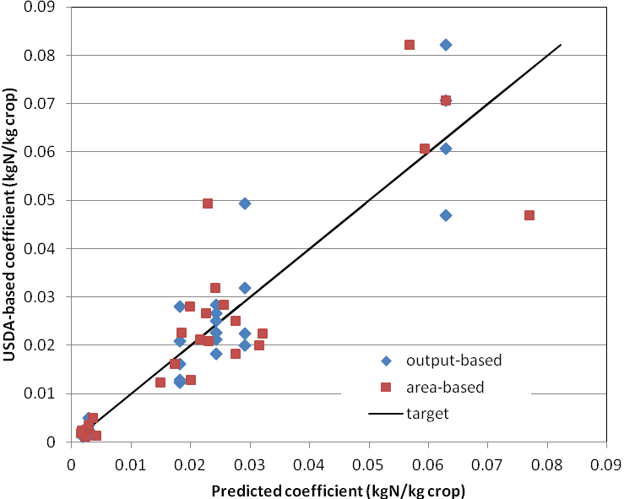
Figure 1. Fertilizer use coefficients (kg N / kg crop) on all crop-AEZ combinations available in the USDA (2011) cost dataset (y axis), as compared with fertilizer use coefficients calculated by two simpler methods. The first, output-based, assumes that for any region/crop, all AEZs have the same application rates in terms of crop output (kg N / kg crop). The second, land-based, assumes that for any region/crop, all AEZs have the same application rates in terms of land area (kg N / m2); these latter estimates are then converted to kg N / kg crop by dividing by the observed base-year yields.
Method (2) is what was used by Potter and Ramankutty (2010), who took region/crop estimates of fertilizer use (from the IFA) and evenly distributed them across gridded data of harvested area by crop type. This method is not followed in GCAM for several reasons. First, this method would imply that for a given region/crop, the relatively low-yielding AEZs have the highest fertilizer application rates per unit output, which from an economic perspective is counter-intuitive. Second, in our modeling of nonCO₂ greenhouse gas emissions (primarily N₂O) from agricultural production technologies, emissions are calculated based on crop output rather than land input, so in this way we stay consistent with our past work on the topic. Third, analysis of the USDA data for the USA indicates that while both methods aren’t all that great as predictors of actual fertilizer use, the output-based method generally does a better job than the land-based method.
There is a wide body of literature that points out that fertilizer use in agroecosystems is dictated by two factors: the tissue nitrogen content of the plant being grown, and the fertilizer recovery efficiency of the agro-ecosystem (e.g. Cassman et al. 2002; Crutzen et al. 2008). Given that the tissue nitrogen content of any given crop is constant, the key question is whether fertilizer recovery efficiency (RE_{N}) can be expected to systematically change across AEZs, and across a distribution of yields, within any country. Cassman et al. (2002) demostrated a positive relationship between RE_{N} and yield in a historical time series in the USA, which would favor a land-based allocation method similar to Potter and Ramankutty (2010). However the USDA data indicate that within any time period, the lowest RE_{N} values are actually observed on the relatively high-yielding, high-precipitation AEZs, presumably due to higher rates of nitrate leaching.
In summary, this issue is complicated, and the present methods used should not be seen as final. We should improve our downscaling of fertilizer use from region/crop to region/crop/AEZ by incorporating more detailed data as it becomes available.

Future Consumption
The primary purpose of the present representation is to allow incorporation of a multiple-technology approach, wherein two discrete technologies will compete: one with relatively low inputs and low yields, and a second with high inputs and high yields. The average fertilizer use for any crop, region, and AEZ will then be endogenous, a function of developments in the energy and land systems in the model. For this reason, no time has been invested into defining future fertilizer use coefficients for the current model input files; base-year fertilizer input-output coefficients are simply rolled forward. Fertilizer demand will increase with crop output, and the fertilizer intensity of agricultural production per unit land area will increase with assumed productivity growth, but the fertilizer demands per unit crop production will not change from the base year values.
Also important for future fertilizer demands, the coefficients assumed for bioenergy are simple, calculated from Adler et al. (2007). Woody bioenergy crops are assigned 0.21 kgN per GJ crop, or 0.0037 kgN per kg crop. All others are assigned 0.36 kgN per GJ crop, or 0.0063 kgN per kg crop. These coefficients do not vary by region, time period, or AEZ. This is an area for future research; we will presumably need to build our own dataset of future yields that is consistent with our scenarios of bioenergy yields, and that is consistent with outputs from detailed crop models.
Note that having a fertilizer coefficient on bioenergy will create simultaneities between biomass, refining, and fertilizer production. Including biomass- or electricity-based fertilizer production technologies, which would be reasonable (we have similar technologies in our hydrogen-for-energy sector), would make this worse. If this causes model solution problems, we may need to address this issue in some fashion.

Agricultural Production Cost Adjustment
The costs of all crops that consume fertilizer are adjusted to account for the fertilizer costs that are now endogenous. While the USDA cost sheets do have a line item called “Fertilizer” that could be deducted from the cost estimates, such a method would neglect the fact that the fertilizer costs, and input-output coefficients, vary by region, in ways that are actually modeled. Moreover, this item includes manure, soil conditioners, and non-N fertilizers. As such, it doesn’t provide an accurate proxy for the costs that are now endogenous. Instead, the initial non-land variable cost is adjusted for the fertilizer cost, calculated as the fertilizer input-output coefficient times an initial estimate of the fertilizer price. This initial price estimate is equal to the observed N fertilizer price from 2001 to 2005 in the USA, based on the prices of anhydrous ammonia ($0.139/kg N in 1975$; $363/tNH₃ in 2007$; USDA 2012).

Fertilizer Production
As noted above, total regional fertilizer production is taken from the FAO RESOURCESTAT data, with a small adjustment to ensure that global production balances global consumption. In order for full incorporation into the GCAM regions’ energy systems, the following steps are implemented:
- Fertilizer production in the base year is assigned to three fertilizer production technologies, according to base-year data on fertilizer production in different regions
- Fertilizer production technologies are assigned energy input-output coefficients, using region-specific estimates for the three existing technologies, and a global set for future (CCS) technologies.
- Fertilizer production technologies are assigned non-energy costs (same for all regions).
- The energy inputs to fertilizer manufacturing are disaggregated between industrial energy use and industrial feedstocks, and deducted from the respective consumption sector in each region. Where negative values result from this calculation, adjustments are implemented.
Steps (1), (2), and (3) are detailed below, and are generally straightforward. However, for step (4), note that this method does not dynamically calculate adjustments to the characteristics of different regions’ fertilizer production sectors in order to ensure non-negative values in the remaining industrial sector. There are a number of potential causes for negative values, and a number of fixes could be reasonably implemented that would address the issue. The current processing code simply prints out an error message along with any region/fuel/year combinations that have negative values, and points the user to the appropriate input tables to adjust (in the Assumptions folder).

Characterization of Production Technologies
Base-year fertilizer production is disaggregated to three production technologies: natural gas steam reforming, coal gasification, and partial oil oxidation. This is done using IEA (2007; see Figure 2). Most fertilizer globally is produced from natural gas, with the exception of China (coal-based) and India (oil-based; Schumacher and Sathaye 1999). Each of these technologies in each region is associated with an input-output coefficient in GJ per ton of NH₃, also from IEA (2007). Note that this input-output coefficient needs to be converted to GJ per kg N (divide by 1000, divide by 14/17) for GCAM.
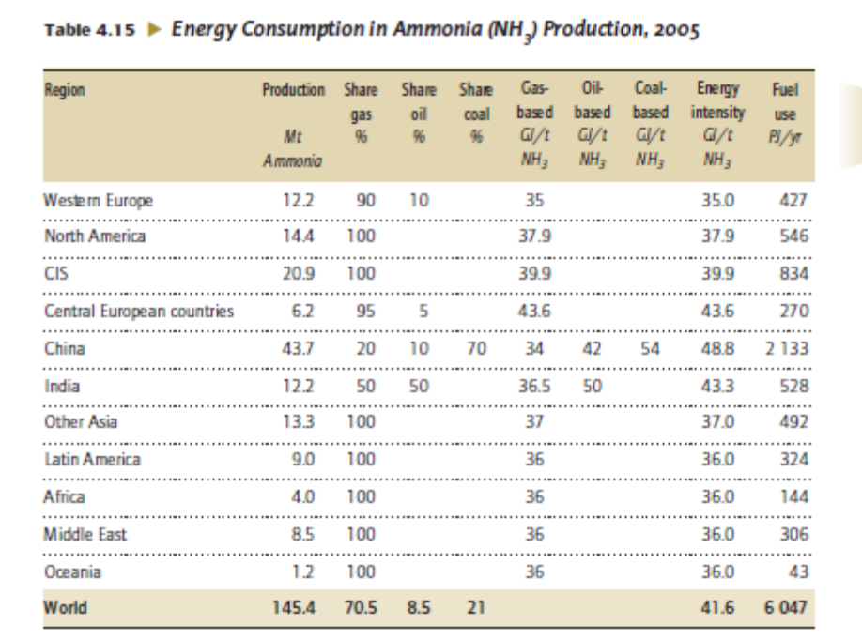
Figure 2. Ammonia production technology characteristics for eleven global regions in IEA (2007).
The vast majority of the energy used in ammonia production is in production of hydrogen (Schumacher and Sathaye 1999), so for deriving the energy intensities of CCS technologies, the H2A model inputs are used. The electricity in the H2A model inputs (whether produced or consumed) is converted to primary fuel equivalent assuming a 40% conversion efficiency. The total primary energy consumption of the CCS technology is divided by the standard technology to calculate an adjustment factor that is assumed to apply to the fertilizer production technologies as well. Including technologies with CCS is one of the benefits of explicitly modeling fertilizer production in GCAM; ammonia production is known to be a good candidate for application of CCS technologies (Dooley et al. 2006), given the high purity and magnitude of the CO₂ stream from the chemical reactions. At present in GCAM, none of the CO₂ from general industrial energy or feedstock use is allowed to be captured and stored.
The non-energy costs of fertilizer production technologies are calculated as follows. For the USA, where all fertilizer is produced by natural gas steam reforming, the non-energy costs are calculated based on the observed average fertilizer price in the USA between 2001 and 2005 ($0.139/kg N in 1975$; $363/tNH₃ in 2007$; USDA 2012), minus the fuel cost in the USA region, using GCAM’s “wholesale gas” prices for the USA region. In this way, total fertilizer costs may vary by region, based on different prices of gas in the base year, and different input-output coefficients on fertilizer production, which can raise or lower the fuel portion of the cost. However the non-energy cost is the same value in all regions. For all other technologies, the non-energy costs are calculated using the arithmetic cost difference from natural gas steam reforming in the H2A model input data, with the latter transformed to indicate costs per unit of nitrogen rather than hydrogen. The arithmetic costs are used (rather than the cost ratios) because our non-energy costs also include delivery charges, which shouldn’t differ between production technologies. Note that by this method, the fertilizer costs in China are higher than any other region.
For oil, the cost calculation is complicated by the lack of differentiation in GCAM between the different products of crude oil refining. The oil-derived fuel used to produce ammonia is a thick, heavy hydrocarbon whose market prices are closer to coal than to diesel fuel, motor gasoline, LPG, and the other products responsible for the “refined liquids” prices in GCAM. For this reason, the non-energy cost is calculated as the desired fertilizer price ($363/t NH3, the price assumed for the USA) minus the costs of the fuel, which yields a non-energy cost that is slightly negative (and therefore re-set to 0).
This calibration to the end-user price is necessary because the technology is being phased out in India (Rafiqul 2005), the one region where it has substantial market share. If we calculated the market prices in the base year using a reasonable non-fuel cost and GCAM’s fuel costs (for “refined liquids industrial”), then the fertilizer prices would be over $600/tNH3, and would drop to about $350 when the technology is phased out, which would have unintended and unrealistic cascading effects on crop prices and land profit rates. The current method handles the economics of the phase-out of partial oil oxidation fertilizer production reasonably well; the price still falls about 15% from 2005 to 2035 in India. Given that the fertilizer cost accounts for about 10-30% of the costs of crop production in this region, the price “shock” from the phase-out of the oil-based production technology should be generally less than 5%.
Table 2. Technology non-fuel costs and input-output coefficients in the 2005 time period, for all GCAM regions.
 | Non-fuel cost | Input-output coefficient
Technology | 1975$/kg N | GJ/kg N
natural gas steam reforming | 0.070 | 0.0201
natural gas steam reforming w/CCS | 0.108 | 0.0213
coal gasification | 0.205 | 0.0397
coal gasification w/CCS | 0.266 | 0.0425
refined liquids | 0.000 | 0.0288

Deduction from Industrial Energy Use and Industrial Feedstocks
The deduction from industrial energy would be straightforward, except that the fertilizer production process uses the input fuel both as energy (combustion/heat) and feedstocks (material production). The IEA accounting convention on feedstock use in the chemical and petrochemical industry (IEA 2009) is that the “feedstock” use is equal to the energy content of the manufactured product. For ammonia, the energy of the product is calculated based on the hydrogen content (IEA 2007); hydrogen has an energy content of 120 GJ/t (LHV), and ammonia is 18% hydrogen by mass (3/17), so the feedstock energy content for ammonia production is 21.2 GJ/tNH3, or 0.0257 GJ/kgN. This applies equally to all production technologies. Note that in our representation of the fertilizer production technologies, we do not differentiate between feedstocks and energy, because there is no reason to do so. We only need to be careful that our input-output coefficients in future periods never go below 0.0257, because this would be thermodynamically impossible. But for the deduction from industrial energy/feedstock, the differentiation between energy and feedstocks does already exist in the IEA Energy Balances (IEA 2010), and therefore in GCAM’s calibration data.
Therefore, the amount of energy to deduct from “industrial feedstocks” is calculated for each region as the amount of ammonia production by the given fuel type, multiplied by the energy content of the hydrogen in the ammonia. The amount to deduct from “industrial energy use” is calculated as the total fuel input minus the feedstock quantity.
Several regions have negative industrial energy or feedstock demands from this method. This may be due to a variety of reasons, such as (a) accounting discrepancies between what is “energy” as opposed to “feedstocks” that are in the IEA energy balances, (b) small countries that are regions in GCAM that have different characteristics than those specified in the IEA’s eleven macro-regions for ammonia production, (c) differences in technology shares between 1990 and 2005 that are not picked up because our input data only has 2005 specified. For instance, Korea, by being in the IEA’s “Other Asia” macro-region (Asia minus the Middle East, Former Soviet Union, China, and India), is assigned a 100% share to natural gas steam reforming. Korea’s natural gas consumption by industry in 1990 was less than a rounding error most anywhere else, and in both periods there is no gas considered as feedstocks.
The regions with negative values are addressed through two tables that are read in a priori. One table adjusts the shares by different production technologies, and decreases the shares of natural gas steam reforming in Korea and India in 1990. The second table re-maps energy from feedstocks to energy, and is used in Japan and Korea in 2005, where the feedstocks were too low to incorporate the fertilizer disaggregation, but there was enough gas in “industrial energy use.”

Model Output

The Reference Scenario

The Agricultural System
This section presents some results relevant for assessing the fertilizer component of GCAM, and the effect of this new commodity on the model results more broadly. First, recall that the non-land variable costs of crops in all regions are adjusted so that the total costs of crop production in the base year are not changed by including fertilizer explicitly. As such, if fertilizer prices stay constant in future periods, then there should be no effect on the prices of crops. In general, the reference scenario bears this dynamic out, shown in Figure 3.
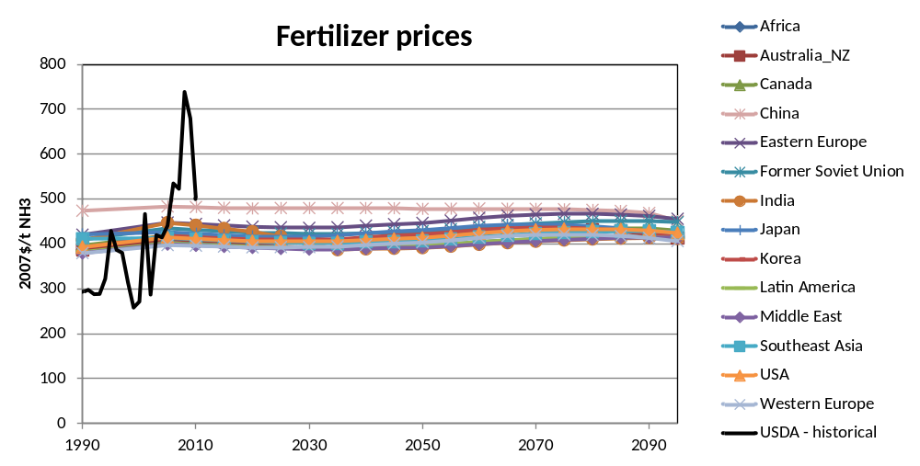
Figure 3. Reference scenario N fertilizer prices by GCAM region, indicated in 2007$ per ton of anhydrous ammonia. Also shown are historical prices from USDA (2012).
As noted in the description of the fertilizer non-energy costs, the prices in China are higher than elsewhere because most fertilizer is manufactured from coal, which is a more expensive production technology than natural gas steam reforming. Nevertheless, the price in all regions and time periods is well within the observed historical time series from USDA (2012), which is characterized by a series of spikes. In any case, any other inter-regional differences in base-year fertilizer prices reflect differences in (a) shares of the oil-based fertilizer production technology (also more expensive than natural gas steam reforming), (b) energy intensities of fertilizer manufacturing, and (c) gas prices. As it relates to the agricultural sector, disaggregating the fertilizer component from the non-land variable costs does not have any significant effects on agricultural commodity prices or production quantities, with the possible exception of biomass in the near term, demonstrated in Figure 4.
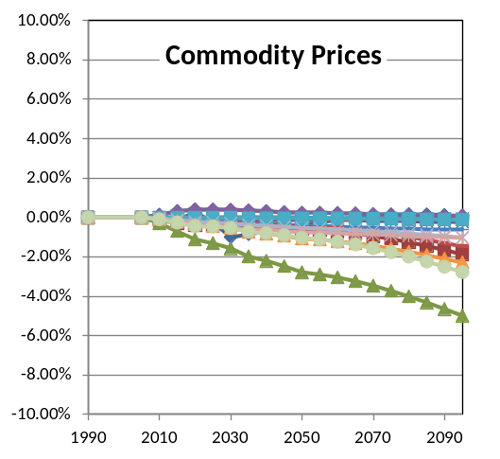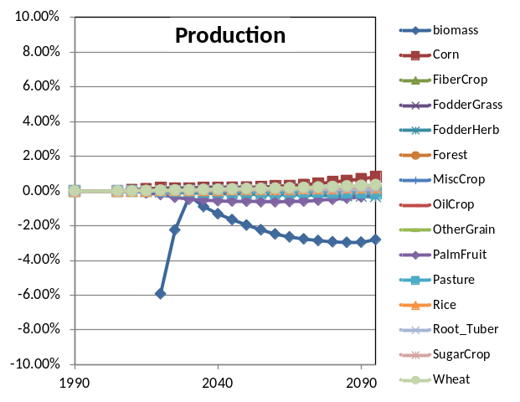
Figure 4. Difference in agricultural commodity prices and production quantities from the corresponding reference scenario that does not include the fertilizer component, expressed in percentage terms.
Regarding biomass production in 2020, while including fertilizer does decrease it by 6%, the switch to the new data system increased it by about 20%, as this switch entailed assigning higher yields to certain bioenergy crops whose yields had been overlooked in the development of GCAM 3.0. Figure 5 highlights that this marginal effect of fertilizer is small, particularly in the context of the following decades. In any case, the effects of dynamically including fertilizer on the agricultural sector appear to be small, in a reference scenario.
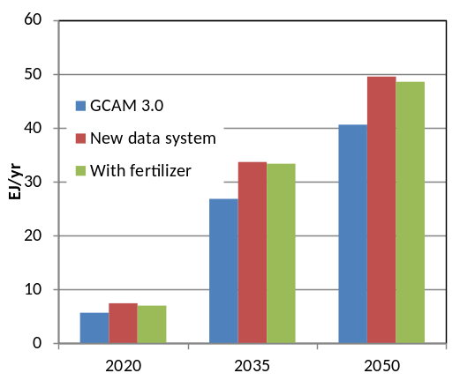
Figure 5. Global purpose-grown bioenergy in GCAM 3.0, with the new data system but without fertilizer, and with the new data system and including fertilizer.

The Energy System
Generally, fertilizer production in future periods does not see any dramatic inter-regional shifts from the base-year shares, with China remaining the largest producer through the end of the century, and with greater than two thirds of production taking place in the following five regions: China, Southeast Asia, India, the Former Soviet Union, and the USA (Figure 6). The oil-based fertilizer production technology is phased out in all regions, consistent with Rafiqul (2005). China accounts for all of the world’s coal-based fertilizer production through the end of the century, as this technology is assumed to be unavailable in all periods elsewhere. Future users may want to remove this conservative assumption.
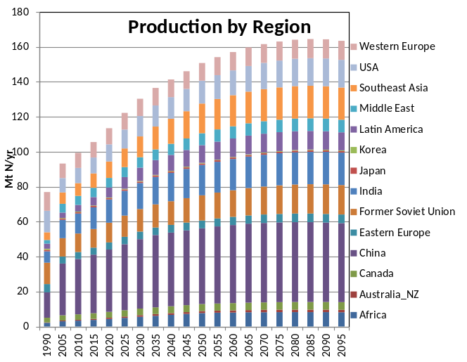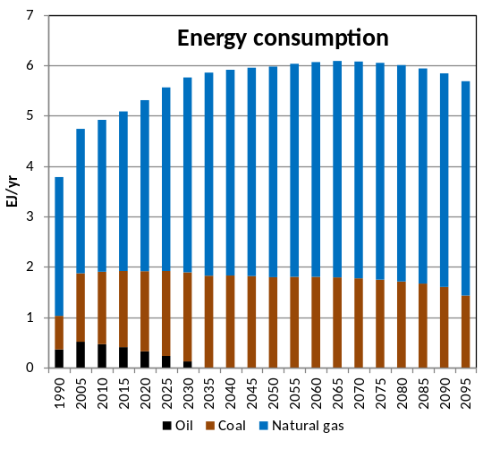
Figure 6. Reference scenario fertilizer production by region, in Mt N per year, and energy inputs to fertilizer production, in EJ per year.
Figure 6 also demonstrates the efficiency improvements assumed in the scenario; the scenarios assume 0.5% per year improvement for all technologies through 2050, and 0.25% per year thereafter. For the USA, this yields an improvement from today’s 37.9 GJ/tNH₃ (IEA 2007) to an end-of-century average energy intensity of 27 GJ/t NH₃. The current best available practice is 28 GJ/tNH₃(Rafiqul 2005), and the theoretical limit on efficiency improvements is 21.2 GJ/tNH₃ (this would be a production technology with zero energy use; IEA 2007). In other words, there is still some room if future users want to improve the energy intensity of fertilizer manufacturing, but care should be taken not to go below the thermodynamic limits.
Within the energy system, the disaggregation of fertilizer energy use can be expected to influence total future industrial energy use, as the disaggregated component will have a separate demand driver from the remaining energy use. However, as shown in Figure 6, the fertilizer component of industrial energy demand was about 5 EJ/yr in 2005, only about 3% of total global industrial energy use (including feedstocks; see Figure 7). This decreases over time, so on the whole, the effect of explicitly modeling fertilizer production on global industrial energy consumption is negligible in the reference scenario, shown in Figure 7.
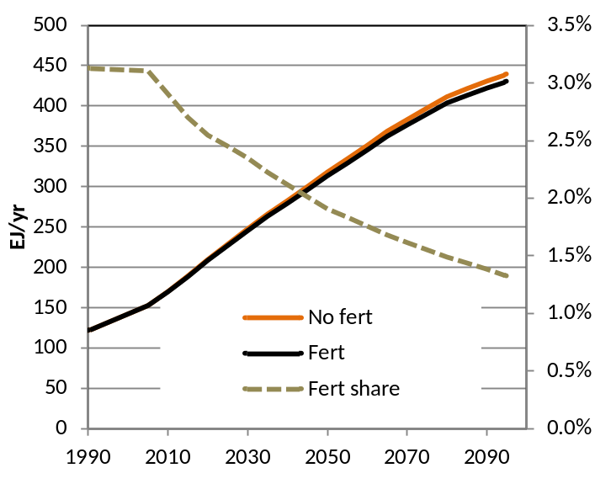
Figure 7. Global industrial energy use, with (“Fert”) and without (“No Fert”) fertilizer explicitly represented. Also shown is the share of total industrial energy use that is for fertilizer manufacturing, in the scenario where it is represented.

Policy Scenario
The remainder of this document assesses the output in a scenario with a carbon price of $15/tC (1990$) in 2020, increasing at 5% per year, generally comparing the results with and without the fertilizer module included. End-of-century CO₂ concentrations are between 522 and 523 ppmv in each scenario. The CO₂ emissions price applies to all of the energy consumed for fertilizer production, as none of the carbon in the fuels ends up sequestered in the product. However, fertilizer production by natural gas steam reforming with CCS is allowed in all regions, and coal gasification with CCS is allowed in China. As indicated in Table 2, these technologies have higher non-fuel costs and higher energy intensities, but are assigned CO₂ removal fractions of 90%. Global fertilizer production by technology is shown in Figure 8.
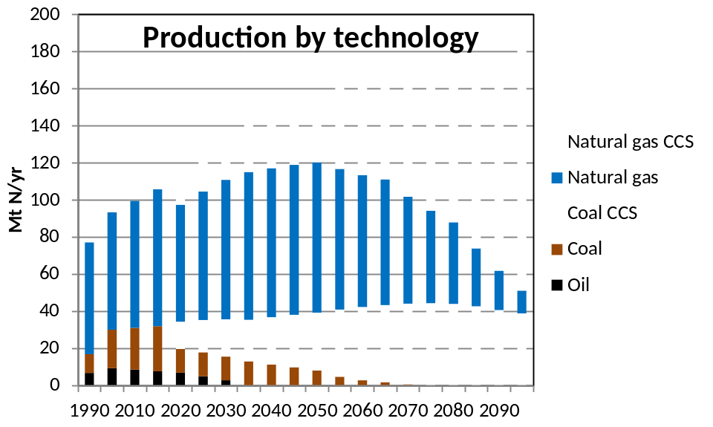
Figure 8. Global N fertilizer production by technology, with climate policy.
The CO₂ prices in this scenario force a phase-out of the freely emitting coal-based production technology in China by mid-century, but the gas-based production technology doesn’t see a full phase-out even at the end of the century, due to the regional heterogeneity in CO₂ reservoir capacity. This regional heterogeneity is reflected in the fertilizer prices, shown for selected regions in Figure 9. In the USA and China, which have a high amount of CO₂ storage reservoirs, the fertilizer price increase is mitigated by the use of CCS. However in India, the limited capacity of CO₂ storage reservoirs makes this option more costly, particularly towards the end of the century. Note that the current representation does not explicitly model trade of fertilizer; fertilizer trade is handled in similar fashion to meat trade, wherein the base-year net trade flows between GCAM regions in 2005 are rolled forward to all future periods. As such, in regions with high-cost fertilizer such as India, there is no option to increase imports from regions with access to less costly production technologies.
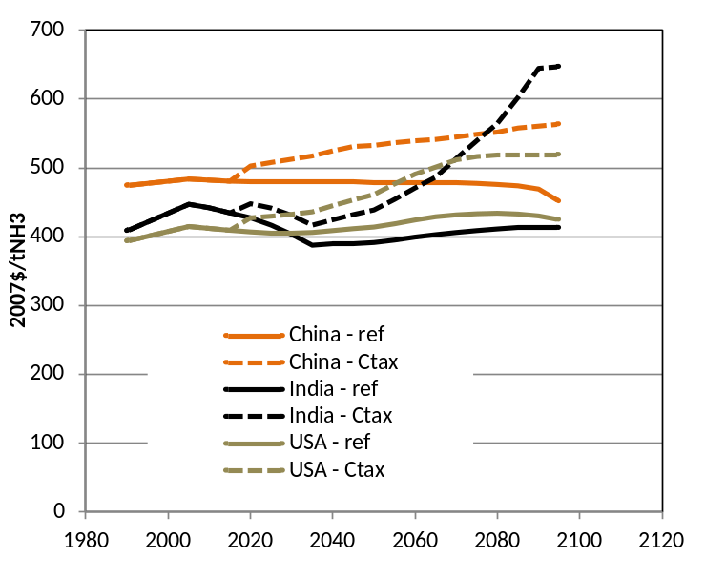
Figure 9. Fertilizer prices in selected regions, reference and policy.
In the agricultural system, the present representation assigns a fixed fertilizer input-output coefficient to all region/crop/AEZ combinations; therefore, for any region, crop, and AEZ, there is no capacity to adjust fertilizer application levels in response to different fertilizer prices. However, there can be inter- and sub-regional shifting in production induced by fertilizer costs, as higher fertilizer costs in any region/crop/AEZ will directly increase the costs of production, and lower the land profit rate.
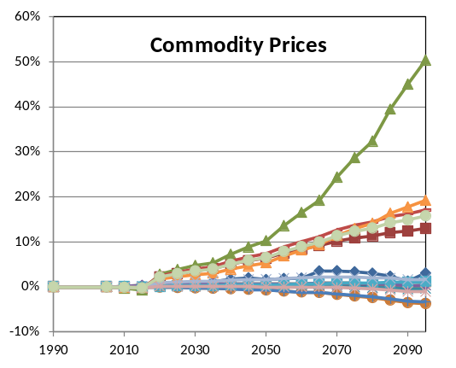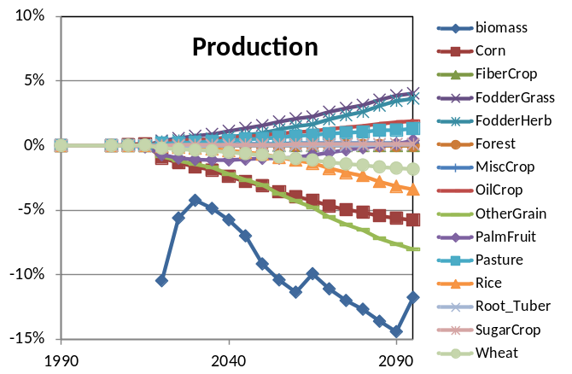
Figure 10. Global primary agricultural commodity price and production changes due to including fertilizer in the representation, with a climate policy.
At the global level, adding fertilizer to the representation does affect global commodity markets, shown in Figure 10. The crop that sees the most dramatic increase in prices—FiberCrop, whose fertilizer intensity is quite high in cotton-producing regions—has fixed demand over time, so at the global level there is no change in its production. Still, the effect of explicitly disaggregating fertilizer is generally to amplify the effects of carbon pricing on agricultural commodity prices, for the following crops: cotton, corn, the OilCrop composite, rice, and wheat. All others see little or no price changes that are due to explicitly modeling fertilizer. Note that while the magnitude of these price increases may seem high, even without considering fertilizer, the carbon price causes agricultural commodity prices to increase by an average of over 400% at the end of the century.
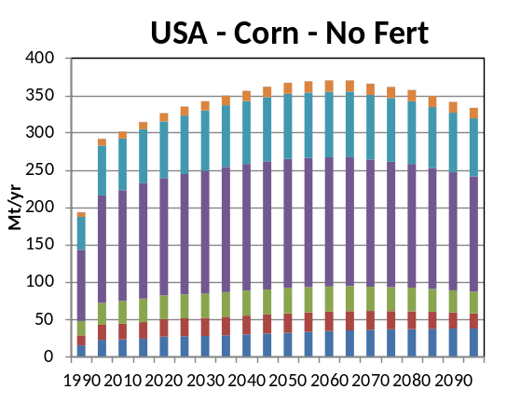 | 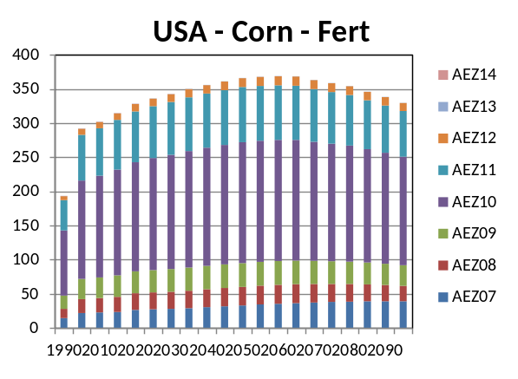
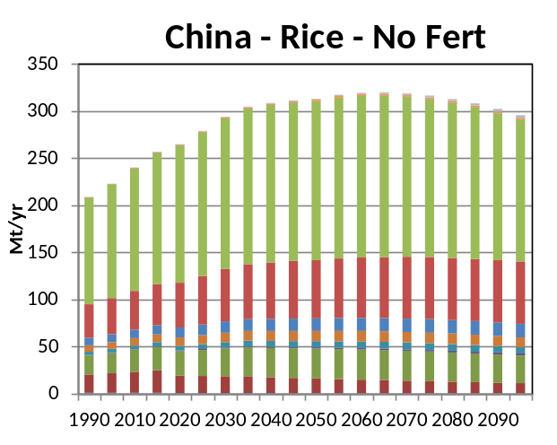 | 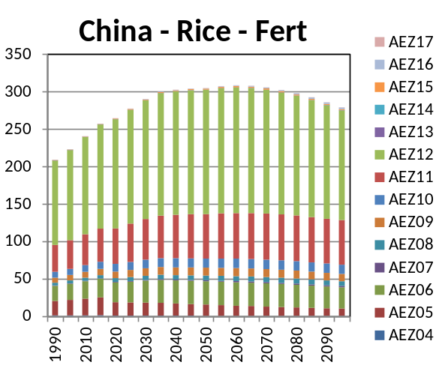
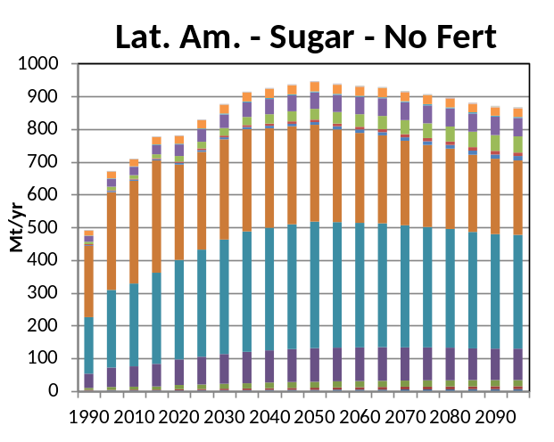 | 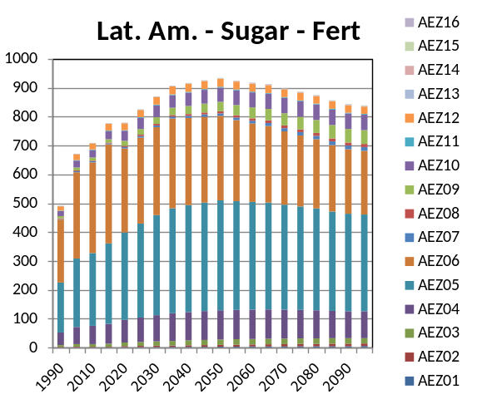

Figure 11. Selected region-crop production quantities, with and without fertilizer explicitly modeled, with a climate policy.
highlights several region and crop combinations that are important for the global agricultural sector; as shown, dynamically including fertilizer costs does not have a strong effect on these regions and crops.
As a final assessment, Figure 12 shows the global use of fertilizer by crop type, in the reference and policy scenario. Most of the demands are reasonably stable over time, and in terms of the portional allocations, the base year shares are generally preserved in the both the reference and the policy scenario, with the exception of dedicated bioenergy crops. In fact, the increase in bioenergy in the policy scenario does lead to an end-of-century increase in the demand for fertilizer in the policy scenario. However, this increase in demand induced by the policy should be interpreted with caution, as again the current representation doesn’t allow agricultural management practices to adjust in response to fertilizer prices; the only ways to reduce fertilizer use are to shift crop production towards regions/AEZs with low assigned fertilizer input-output coefficients.
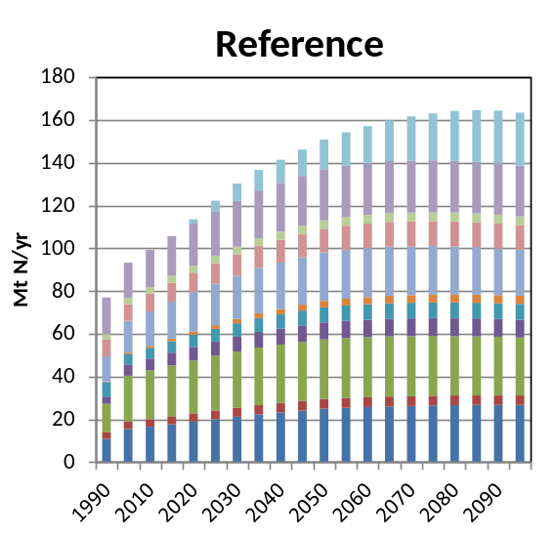 | 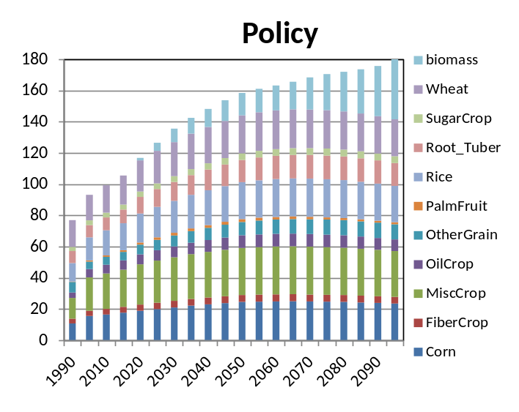
Figure 12. Global disposition of fertilizer, in a reference and policy scenario.

Future Directions
In the fertilizer production sector, future work should seek to incorporate more technologies, perhaps the full technology set that is available in each region for producing hydrogen for energy. We might ultimately want to integrate the hydrogen production sector with the fertilizer production sector. Adding biomass as a production technology would also allow the model another place for biomass with CCS.
In the agricultural sector, the next step is going to be to disaggregate the production technologies into two separate, competing technologies, calibrated so that base-year observed yields, production quantities, fertilizer demands, and land areas are conserved. Then in the future the average fertilizer application rates will be endogenous, a function of fertilizer prices, crop prices, and the value of the land more broadly.

References
Adler, P., S.J. Del Grosso, and W.J. Parton. 2007. Life-cycle assessment of net greenhouse gas flux for bioenergy cropping systems. Ecological Applications 17: 675-691.
Cassman, K.G., A. Dobermann, and D.T. Walters. 2002. Agroecosystems, nitrogen-use efficiency, and nitrogen management. Ambio 31: 132-140.
Crutzen, P.J., A.R. Mosier, K.A. Smith, and W. Winiwarter. 2008. N₂O release from agro-biofuel production negates global warming reduction by replacing fossil fuels. Atmospheric Chemistry and Physics 8: 389-395.
FAOSTAT, 2011. ResourceSTAT. Food and Agriculture Organization of the United Nations. http://faostat.fao.org/site/575/default.aspx#ancor
FAOSTAT, 2011. PRODSTAT. Food and Agriculture Organization of the United Nations. http://faostat.fao.org/site/567/default.aspx#ancor
Dooley, J.J., R.T. Dahowski, C.L. Davidson, M.A. Wise, N. Gupta, S.H. Kim, and E.L. Malone, 2006. Carbon Dioxide Capture and Geologic Storage. Global Energy Technology Strategy Program, http://www.battelle.org/news/06/CCS_Climate_Change06.pdf
Heffer, P. 2009. Assessment of Fertilizer Use by Crop at the Global Level, 2006/07 – 2007/08. AgCom/09/28, International Fertilizer Industry Association (IFA). http://www.fertilizer.org/ifacontent/download/20485/294309/version/1/file/AgCom.09.28+-+FUBC+assessment+at+the+global+level+%282006+%2B+2007%29.pdf
IEA, 2007. Tracking Industrial Energy Efficiency and CO2 Emissions. International Energy Agency. http://www.iea.org/textbase/nppdf/free/2007/tracking_emissions.pdf
IEA, 2009. Chemical and Petrochemical Sector: Potential of Best Practice Technology and Other Measures for Improving Energy Efficiency. International energy Agency, http://www.iea.org/papers/2009/chemical_petrochemical_sector.pdf
IEA, 2010. Energy Balances of OECD and non-OECD Countries, 1960-2008 and 1971-2008. International Energy Agency.
Liao, H. 2008. The Evolution of Fertilizer Subsidies in China. IFA Crossroads Asia-Pacific, Melbourne, Australia, December 2008.
Potter et al., 2010. Characterizing the spatial patterns of global fertilizer application and manure production. Earth Interactions 14.
Rafiqul, I., C. Weber, B. Lehmann, and A. Voss, 2005. Energy efficiency improvements in ammonia production—perspectives and uncertainties. Energy 30: 2487-2504.
Schumacher, K., and J. Sathaye, 1999. India’s Fertilizer Industry: Productivity and Energy Efficiency. LBNL-41846, Lawrence Berkeley National Laboratory, http://ies.lbl.gov/iespubs/41846.pdf.
USDA, 2011. Commodity Costs and Returns. United States Department of Agriculture, Economic Research Service. http://www.ers.usda.gov/Data/CostsAndReturns/
USDA, 2012. Fertilizer Use and Price, Table 7: Average U.S farm prices of selected fertilizers, 1960-2011. United States Department of Agriculture, Economic Research Service. http://www.ers.usda.gov/Data/FertilizerUse/Tables/Table7.xls
WTO, 2010. Trade Policy Review, China, Geneva. WT/TPR/S/230, World Trade Organization. http://www.wto.org/english/tratop_e/tpr_e/s230-04_e.doc

China’s fertilizer prices are subsidized at many points along the supply chain (Liao 2008), and the price is “guided” by the government (WTO 2010, p. 75, footnote 21), so it is likely that the observed historical market prices—generally comparable to the prices in the USA—do not accurately reflect the full production costs. The current method yields a weighted average fertilizer price in China of about $570 per ton NH₃ in 2005.
This is complicated, but for the energy/feedstock partitioning we follow the IEA’s methods and use the energy content of the hydrogen in the ammonia, rather than the energy content of ammonia itself, which is slightly lower (18.7 GJ/t). The extra 2.5 GJ/t could theoretically be captured and used, but in practice this is not done, and in any case, the whole reason why we are interested in this energy/feedstock partitioning is to be consistent in our deduction from the industrial sector, so we need to use the IEA’s accounting methods.

